DATA VISUALIZATION USING POWER BI
SALES DATASET
Dataset link :
https://www.kaggle.com/datasets/suraj520/dataset
Load dataset:
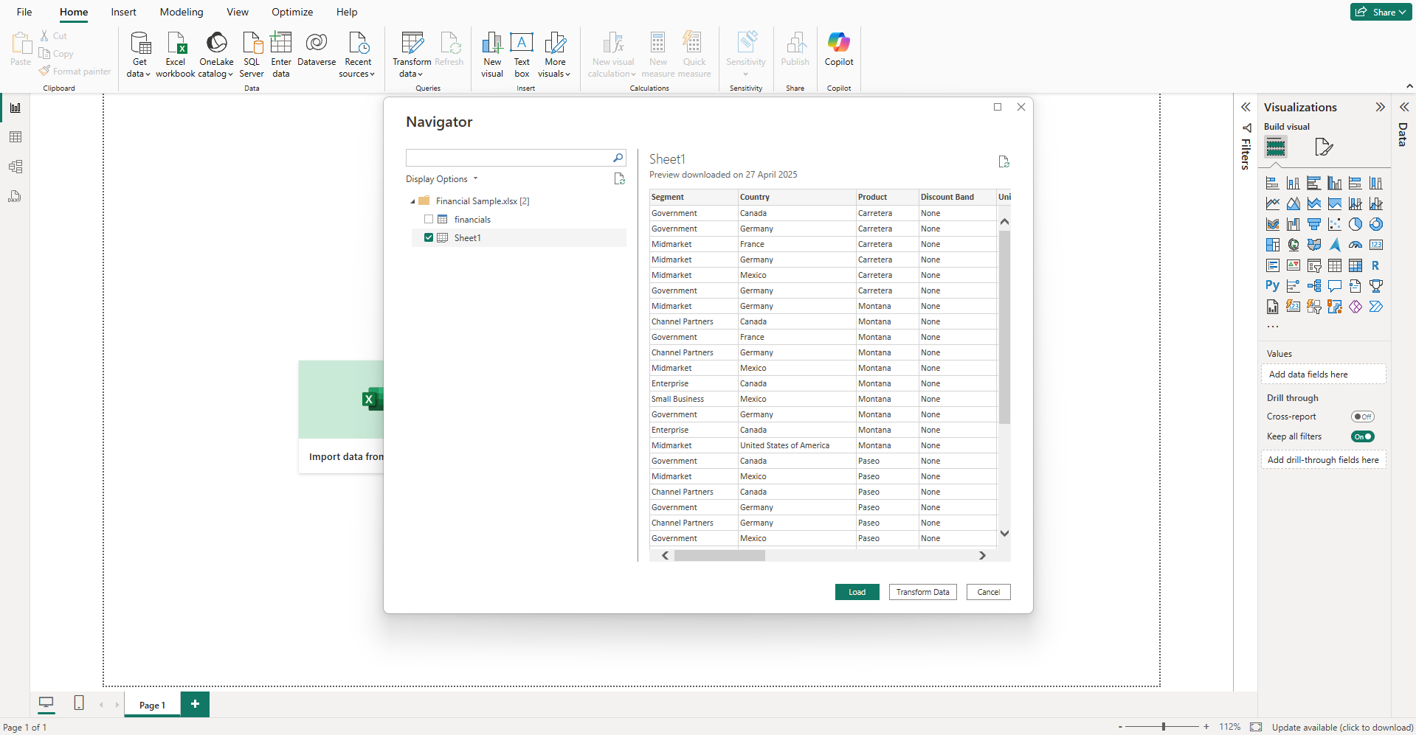
Data transformation using Power Query editor:
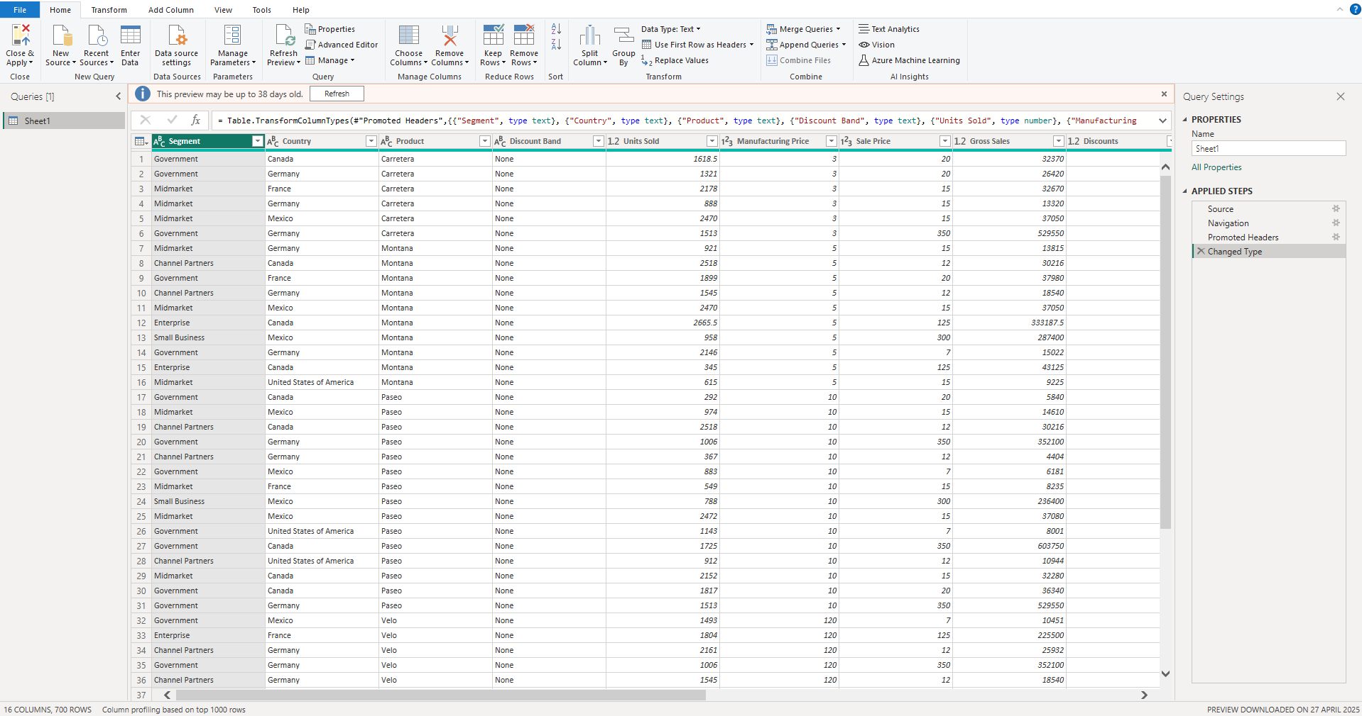
Performance analyser :
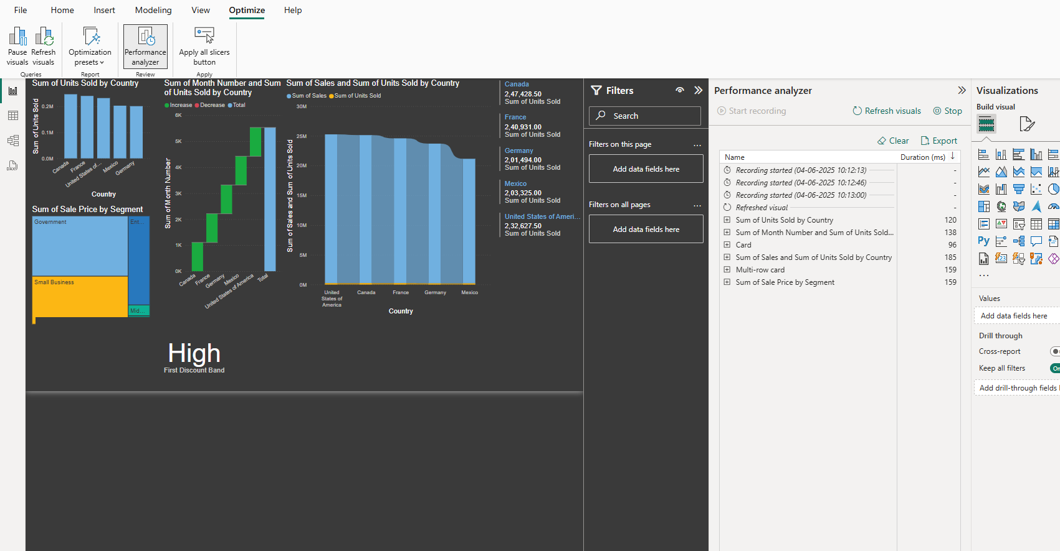

Managing relationships:
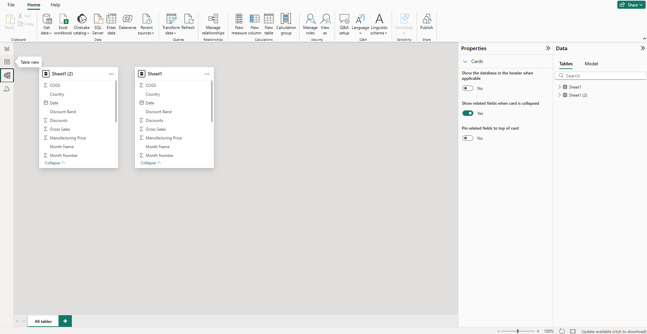

Finding outlier using advanced techniques:
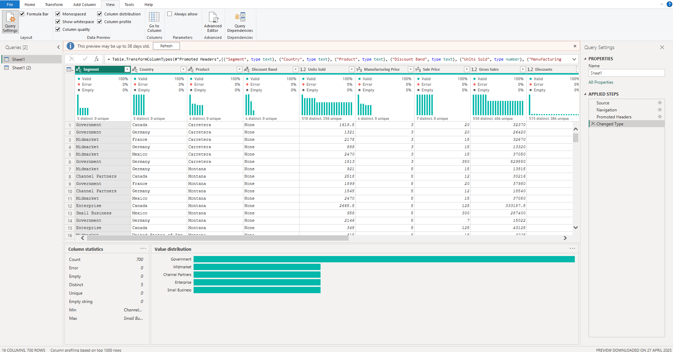

Dashboard:
